Python

Python through commando prompt:

1. Open command promt by pressing windows button+R
2. Check if python is installed in your computer by writing: python --version
3. Write python, and it enters in the program
4. Write a code line for example print(“Hello Python”)

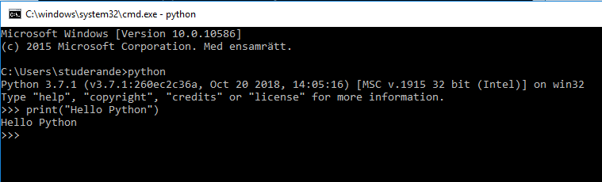

1. If you want to run a text file in Python instead of writing commands in command promt then you chould do following:

* Enter in the folder where your test file is located. For example:

cd \Users\studerande\Desktop\Useful shit\Python exercises

* When you are in, write Python+TextFileName, like in this case Python Test1 or Python Ex_with_sublime

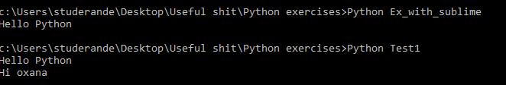

One ca also use a development tool to write the code such as Visual studio. Here we will use PyCharm that we downloaded.

BOOK ADVICE <https://www.cs.uky.edu/~keen/115/Haltermanpythonbook.pdf>

P.S: download ATOM as text editor – (check this video for setting up atom for python! https://www.youtube.com/watch?v=HqhRLvzTihU)

1. Values and Variables:

a=5

b=10

my_variable = 56

string_var="hello" #note that Python persieves string not as a whole word but as separate characters

string_single_quote='string can have single quotes'

print(my_variable)

print(string_var)

print(string_single_quote)

1. Methods

Methods have intendence(4 spaces)

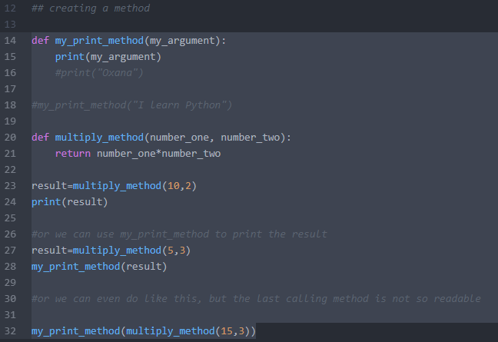

1. Lists and Tupels

The only difference between list and a tuple, is that tuple is immutable- i.e., we cannot increase a tuples size. For example there are ways to increase the size of a list with method like APPEND, but its not possible to do so with tuples. Python has also sets, which are a type of list that contains elements which are unique and unordered.

To append to a list : list.append(the element)

Some examples of code:

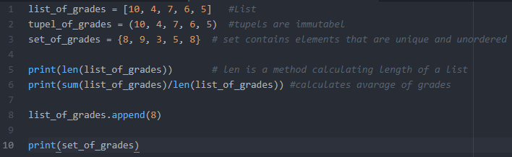

Run the code in cmd(Results):

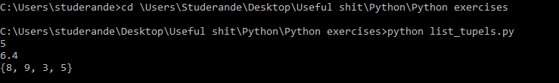

You can append elements to the List but not to the tupple. But what we can do instead to the tuple is that we can add two tuples together.

To add two tuplets together: tupel = tupel + (another tupel)

To add an element to a set : set_grades.add(element)

For example we want to add to our list_of_tupels another tupel list that contains only one element 100. OBS-100 is followed by comma!!!!:

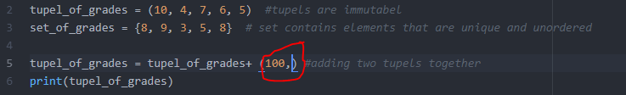

And result is:



OBS we have not changes the tupel we just printed a new tuple!

We can change elements of a list but we cannot do it with the tuple, and sets:

list_of_grades[0]=34 – the first element of the list will be 34

## Advance set of operations

You can unite, or show common elements or what are the elements that differentiate two sets:



1. Looping through array

## Finding the smallest value in an array

Give an initial value for the smallest = None (i.e its equal to nothing)

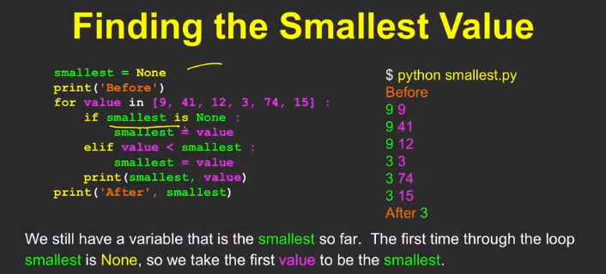

1. List Comprehension

Strip() function cleans white spaces in a list

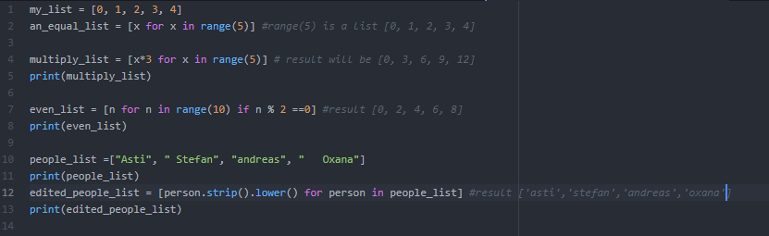

1. Dictionaries

A dictionary is a collection which is unordered, changeable and indexed. In Python dictionaries are written with curly brackets, and they have keys and values.

There are two ways to instantiate a dictionary:

1. thisdict = dict(brand="Ford", model="Mustang", year=1964) //dict() is method or
2. thisdict = {  
     "brand": "Ford",  
     "model": "Mustang",  
     "year": 1964  
   }

Dictionary methods

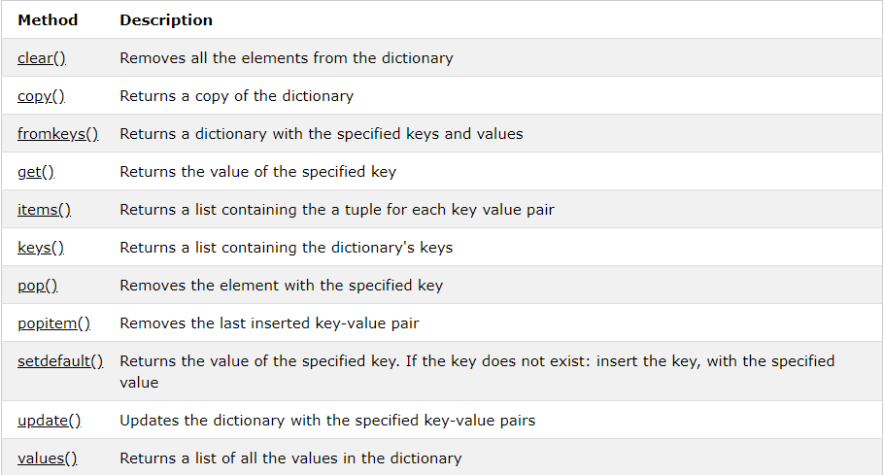

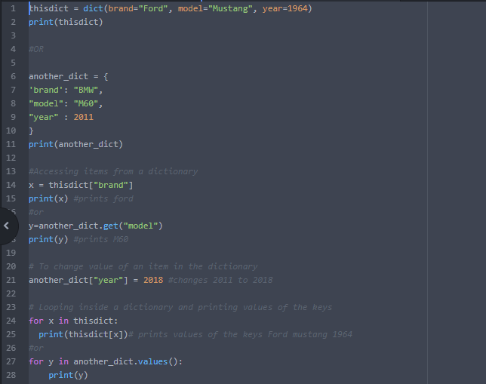

1. Objects in Python

Classes/objects vs Dictionaries- dictionaries cannot do operations on its own data but classes can do.

An example of how to create a class. Classes should always have an init method which takes a self that is an object that we are creating and also any number of arguments after that.

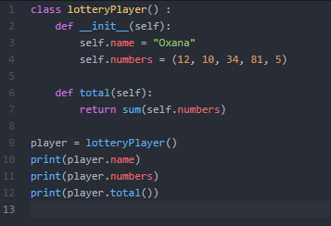

1. Slicing strings

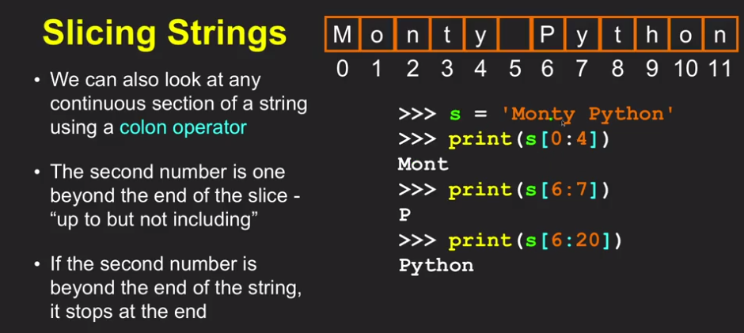

String is an immutable array while list is mutable

Slicing string abc = “A lot of spaces”

List = abc.split() // splits by spaces but u can split by anything just notify split(‘;’)

<<<< Result [‘A’, ‘lot’, ‘of’, ‘spaces’]